***Yves Saint Laurent Libre***

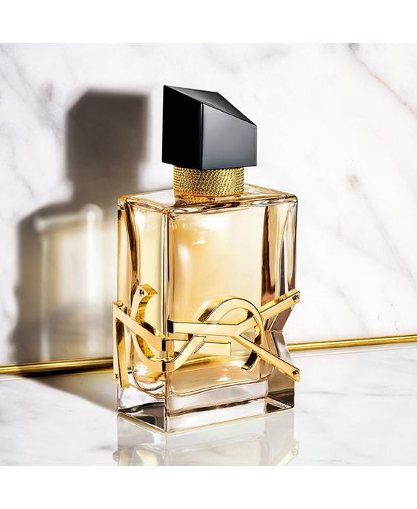

*YSL Libre fragrance opens with an explosion of mandarin orange, black currant and orange leaf essential oil, the lavender composition appears to add softness to the freshness of citrus. Jasmine in the heart creates a delicate beauty that can leave others spellbound for hours, when accompanied by an elegant lavender scent. Because of the oriental style, the last note of Yves Saint Laurent Libre cannot lack the ingredients of musk, vanilla, and cedar to bring a passionate, warm flavor that lasts for hours.*